**VIVEKANAND EDUCATION SOCIETY’S INSTITUTE OF TECHNOLOGY**

**(An Autonomous Institute Affiliated to University of Mumbai**

**Department of Computer Engineering)**

**Department of Computer Engineering**



**Project Report on**

# CloudEye - Cloud Burst Prediction System

Submitted in partial fulfillment of the requirements of Third Year (Semester–VI), Bachelor of Engineering Degree in Computer Engineering at the University of Mumbai Academic Year 2024-25

By

**Asmi Rajbhar - D12A/70**

**Om Patil - D12B/70**

**Ravina Vartak - D12A/68**

**Madhura Golatkar - D12A/25**

**Project Mentor**

Dr. Gresha Bhatia

**University of Mumbai**

**(AY 2024-25)**

**VIVEKANAND EDUCATION SOCIETY’S INSTITUTE OF TECHNOLOGY**

**(An Autonomous Institute Affiliated to University of Mumbai**

**Department of Computer Engineering)**

**Department of Computer Engineering**



**CERTIFICATE**

This is to certify that ***_______________________________________________***of Third Year Computer Engineering studying under the University of Mumbai has satisfactorily presented the project on “***CloudEye - Cloud Burst Prediction System***” as a part of the coursework of Mini Project 2B for Semester-VI under the guidance of  ***Dr. Gresha Bhatia*** in the year 2024-25.

______***_______________***

Date

|  |  |  |
| --- | --- | --- |
| __________________ |  | __________________ |
| Internal Examiner |  | External Examiner |

_________________ __________________ __________________

Project Mentor Head of the Department Principal

Dr. Mrs. Nupur Giri Dr. J. M. Nair

**Declaration**

We declare that this written submission represents our ideas in our own words and where others' ideas or words have been included, we have adequately cited and referenced the original sources. We also declare that we have adhered to all principles of academic honesty and integrity and have not misrepresented or fabricated or falsified any idea / data / fact / source in our submission. We understand that any violation of the above will be cause for disciplinary action by the Institute and can also evoke penal action from the sources which have thus not been properly cited or from whom proper permission has not been taken when needed.

|  |  |
| --- | --- |
| -----------------------------------------  (Signature)  Asmi Rajbhar (70) | -----------------------------------------  (Signature)  Ravina Vartak (68) |
| -----------------------------------------  (Signature)  Om Patil (70) | -----------------------------------------  (Signature)  Madhura Golatkar (25) |

Date:

## Acknowledgement

We are thankful to our college Vivekanand Education Society’s Institute of Technology for considering our project and extending help at all stages needed during our work of collecting information regarding the project.

It gives us immense pleasure to express our deep and sincere gratitude to Deputy HoD **Dr. Gresha Bhatia** (Project Guide) for her kind help and valuable advice during the development of project synopsis and for her guidance and suggestions.

We are deeply indebted to Head of the Computer Department **Dr.(Mrs.) Nupur Giri** and our Principal **Dr. (Mrs.) J.M. Nair ,** for giving us this valuable opportunity to do this project.

We express our hearty thanks to them for their assistance without which it would have been difficult in finishing this project synopsis and project review successfully.

We convey our deep sense of gratitude to all teaching and non-teaching staff for their constant encouragement, support and selfless help throughout the project work. It is a great pleasure to acknowledge the help and suggestion, which we received from the Department of Computer Engineering.

We wish to express our profound thanks to all those who helped us in gathering information about the project. Our families too have provided moral support and encouragement several times.

### Computer Engineering Department

**COURSE OUTCOMES FOR T.E MINI PROJECT 2B**

Learners will be to:-

|  |  |
| --- | --- |
| **CO No.** | **COURSE OUTCOME** |
| CO1 | Identify problems based on societal /research needs. |
| CO2 | Apply Knowledge and skill to solve societal problems in a group. |
| CO3 | Develop interpersonal skills to work as a member of a group or leader. |
| CO4 | Draw the proper inferences from available results through theoretical/ experimental/simulations. |
| CO5 | Analyze the impact of solutions in societal and environmental context for sustainable development. |
| CO6 | Use standard norms of engineering practices |
| CO7 | Excel in written and oral communication. |
| CO8 | Demonstrate capabilities of self-learning in a group, which leads to lifelong learning. |
| CO9 | Demonstrate project management principles during project work. |

**Index**

**Title page no.**

**Abstract**

**Chapter 1: Introduction 4**

1.1 Introduction 4

1.2 Motivation 5

1.3 Problem Definition 5

1.4 Existing Systems 5

1.5 Lacuna of the existing systems 6

1.6 Relevance of the Project 8

**Chapter 2: Literature Survey** 9

A. Overview of Literature Survey 9

B. Related Works 9

2.1 Research Papers Referred 10

a. Abstract of the research paper

b. Inference drawn

2.2 Patent search 12

2.3. Inference drawn 12

2.4 Comparison with the existing system 13

**Chapter 3: Requirement Gathering for the Proposed System 14**

3.1 Introduction to requirement gathering 14

3.2 Functional Requirements 14

3.3 Non-Functional Requirements 15

3.4 Hardware, Software, Technology and tools utilized 15

3.5 Constraints 16

**Chapter** 4**: Proposed Design 17**

4.1 Block diagram of the system 17

4.2 Modular design of the system 18

4.4 Project Scheduling & Tracking: Gantt Chart 20

**Chapter 5: Implementation of the Proposed System 21**

5.1. Methodology Employed 21

5.2. Algorithm and flowcharts 24

5.3. Dataset Description 26

**Chapter 6: Testing of the Proposed System 28**

6.1. Introduction to testing 28

6.2. Types of tests Considered 28

6.3 Various test case scenarios considered 29

6.4. Inference drawn from the test cases 30

**Chapter 7: Results and Discussion 31**

7.1. Screenshots of User Interface (GUI) 31

7.2. Performance Evaluation measures 37

7.3. Input Parameters / Features considered 37

7.4. Graphical and statistical output 38

7.5. Comparison of results with existing systems 38

7.6. Inference drawn 40

**Chapter 8: Conclusion 41**

8.1 Limitations 41

8.2 Conclusion 42

8.3 Future Scope 42

**References 44**

**Appendix I 45**

**Abstract**

This project addresses the critical need for accurate prediction and timely alerts for cloudburst events, which are extreme weather phenomena characterized by intense, localized rainfall. Focusing on vulnerable regions such as the Himalayan states of India, our system integrates advanced weather modeling, machine learning algorithms, and real-time data analysis to enhance forecast accuracy and response times.

The proposed solution incorporates a central monitoring center that processes data from multiple sources, including weather stations, sensors, and satellites. At its core, the system utilizes the CatBoost algorithm, a gradient boosting framework known for its high performance in handling categorical features and minimal preprocessing requirements. This model analyzes historical weather patterns and current atmospheric conditions to predict the likelihood of cloudbursts.

By addressing limitations in existing systems, such as delayed response times and limited

predictive accuracy, this project aims to significantly reduce the impact of cloudbursts on

communities. The system's potential to save lives and minimize property damage through

enhanced prediction accuracy and rapid warning dissemination represents a crucial step towards improving disaster preparedness and resilience in regions increasingly threatened by extreme weather events.

1. **Introduction**

**1.1. Introduction**

Cloudbursts are extreme weather events characterized by short-duration, intense rainfall over a confined area, typically spanning 20-30 square kilometers. These events can lead to devastating flood-like situations within minutes. According to the India Meteorological Department, a rainfall event qualifies as a cloudburst when the precipitation exceeds 100 millimeters in an hour. While heavy rainfall is common during the monsoon season, not all instances meet this threshold. From 1970 to December 2023, 32 cloudburst events have been recorded in India. The state of Uttarakhand is the most affected, with 11 recorded events, a consequence of its mountainous terrain and monsoon climate. Himachal Pradesh follows with 7 recorded incidents. Although cloudbursts are highly localized, their impacts can be far-reaching, often causing significant destruction in surrounding areas.

Cloudbursts predominantly occur in regions with significant orographic influence, such as the Himalayan states, Northeastern India, and the Western Ghats. These events result from moisture-laden air ascending mountainous areas, where it forms towering Cumulonimbus clouds. The upward movement of these clouds, combined with high relative humidity and dense cloud cover, provides the necessary conditions for cloudburst formation.

**1.2. Motivation**

The motivation to develop a cloud burst prediction system stems from the increasing frequency and severity of these extreme weather events, particularly in vulnerable regions like Uttarakhand and Himachal Pradesh. As climate change alters weather patterns, the risk of sudden, intense rainfall leading to catastrophic floods is heightened, necessitating timely and accurate warnings for affected communities. Current weather prediction systems often lack the granularity needed for localized forecasts, making a targeted prediction system essential for enhancing community safety and disaster preparedness. By providing real-time monitoring and alerts, this project can empower local authorities and residents to take proactive measures in the face of imminent danger.

Additionally, raising community awareness about cloudbursts and integrating predictive technology into existing disaster management frameworks can significantly improve response strategies, reduce casualties, and minimize property damage.

**1.3. Problem Definition**

Cloud bursts, particularly in hilly or mountainous regions, are challenging to predict due to

unpredictable weather patterns and limited data availability. To mitigate the risks and enhance community safety, a comprehensive prediction system must be developed. This project focuses on analyzing and predicting early warnings for cloud bursts, offering real-time monitoring and alerts to relevant authorities and the public. The goal is to ensure accurate and timely warnings, enabling effective preparedness and evacuation measures.

**1.4. Existing Systems**

* **MM5 Mesoscale Model**

This system simulates atmospheric processes such as wind convergence, vertical shear, and orographic uplift to predict rainfall events. For example, it successfully forecasted a cloudburst in Shillagarh, Himalayas, 24 hours in advance. However, it faced limitations in spatial accuracy (missing the precise location by a few kilometers) and overestimated hydrometeor content.

* **Machine Learning Model**

This machine learning-based system analyzes meteorological data—such as temperature, humidity, wind gusts, and cloud density—to predict cloudbursts. A study using this model achieved an 86.18% accuracy during the South-West Monsoon season in India. While highly effective for pattern recognition, it relies heavily on comprehensive datasets, which may not always be available.

* **SkySentinel AI-Driven System**

SkySentinel employs AI algorithms and IoT devices to monitor atmospheric conditions like pressure, humidity, and temperature in real time. It identifies patterns indicative of potential cloudbursts and issues timely alerts to vulnerable communities.

Despite its real-time monitoring capabilities, challenges include false positives and limited data availability in remote regions.

**1.5. Lacunas of the Existing System**

* **Real-time Data Integration**

Current cloudburst prediction systems face significant challenges in incorporating real-time meteorological data, which is crucial for enhanced predictive capabilities.

Many mountainous and hilly regions lack dense networks of weather stations, leading to gaps in data collection. In remote areas, limited connectivity hinders the rapid transmission of collected data to prediction centers. Overcoming these limitations is essential for improving the accuracy and timeliness of cloudburst forecasts, potentially providing crucial extra minutes or hours of warning time that could save lives and reduce property damage.

* **Limited Predictive Accuracy**

Cloud bursts are highly localized and intense events that are difficult to predict accurately with current models. The challenge lies in the spatial andtemporal resolution required to capture these phenomena effectively. Cloudbursts can occur over areas as small as 20-30 square kilometers and form rapidly, often lasting for a shortduration. Current models often lack the fine resolution needed to capture these localized events accurately. Furthermore, the influence of complex topography in mountainous regions on local weather patterns is not always adequately represented in existing models. Improving predictive accuracy requires the development of high-resolution models specifically tailored to cloudburst prediction in mountainous terrain, incorporating advanced algorithms and machine learning techniques to better capture the unique characteristics of these extreme weather

* **Additional variables**

Existing systems often fail to fully explore the range of meteorological and geographical factors influencing cloudburst occurrences. This lack of exploration of additional variables limits our understanding of the complex dynamics leading to cloudbursts. Factors such as orographic effects, antecedent soil moisture, and land use changes can significantly influence the likelihood and intensity of cloudbursts, yet they are often overlooked or inadequately modeled in current prediction systems. The impact of mountain slopes on air movement and cloud formation, the role of soil moisture in exacerbating the effects of cloudbursts, and the influence of changing land use patterns on local climate and cloudburst susceptibility are all areas that require further investigation. Addressing this gap requires a more comprehensive approach that incorporates a wider range of variables and their complex interactions, potentially leading to more accurate and reliable cloudburst predictions.

* **Lack of Evacuation Facilities**

Many regions prone to cloudbursts lack adequate evacuation facilities, which severely hampers response efforts when these extreme weather events occur. This deficiency includes a shortage of designated evacuation centers, especially in remote mountainous areas, and a lack of pre-planned evacuation routes that account for potential flash flooding.

Additionally, many regions lack the necessary resources, such as vehicles and supplies, to facilitate rapid evacuation of vulnerable populations. The absence of proper evacuation infrastructure and planning can lead to chaos and potentially catastrophic consequences when a cloudburst occurs. Developing comprehensive evacuation plans, establishing well-equipped shelters, and ensuring the availability of necessary resources for evacuation are crucial steps in improving disaster response in cloudburst-prone areas.

* **Delayed Response Time**

Even when cloudbursts are successfully predicted, there can be significant delays in disseminating warnings to the people in danger. This delay in response time can severely impact the effectiveness of evacuation efforts and make it harder for people to prepare in time. The problem often stems from inadequate communication infrastructure in vulnerable areas, which hinders rapid information dissemination. Existing alert systems may not be optimized for the delivery of time-sensitive information, leading to crucial delays. Furthermore, a lack of public awareness about cloudbursts and appropriate responses can lead to delays in taking action, even when warnings are received. Addressing these delays requires improvements in both technological systems for alert dissemination and public education efforts. Enhancing communication networks, developing more efficient alert systems, and conducting regular public awareness campaigns are essential steps in reducing response times and improving community resilience to cloudburst events.

**1.6. Relevance of the Project**

The relevance of the "CloudEye - Cloudburst Prediction System" project lies in its ability to address the critical need for accurate forecasting and timely alerts for cloudburst events, which are highly destructive and localized extreme weather phenomena. These events often result in catastrophic flooding, loss of lives, and significant property damage, particularly in vulnerable regions such as the Himalayan states of India.

This project is highly relevant because:

1. **Improved Prediction Accuracy:** By utilizing advanced machine learning algorithms like CatBoost, the system analyzes historical weather patterns and real-time atmospheric conditions to enhance prediction accuracy. This is crucial for mitigating the risks associated with cloudbursts.
2. **Real-Time Monitoring**: The integration of data from weather stations, sensors, and satellites enables continuous monitoring of atmospheric conditions, ensuring timely detection of potential cloudburst events.
3. **Disaster Preparedness:** The system's ability to provide early warnings empowers local authorities and communities to implement evacuation plans and safety measures, reducing casualties and minimizing damage.
4. **Addressing Limitations in Existing Systems:** Current systems often suffer from delayed response times and limited predictive accuracy. CloudEye overcomes these challenges by leveraging cutting-edge technology to deliver faster and more reliable alerts.

**2. Literature Survey**

**A. Overview**

The literature survey provides a comprehensive review of existing research and studies related to cloudburst prediction, highlighting key findings, methodologies, and theoretical frameworks. The survey covers studies such as the use of the MM5 mesoscale model to predict cloudbursts in the Himalayas, which successfully forecasted rainfall but with spatial inaccuracies. It also discusses machine learning approaches, like the CatBoost model, which achieved high prediction accuracy by analyzing meteorological factors, emphasizing the critical role of humidity. Additionally, the survey examines AI-driven early warning systems, such as SkySentinel, that use real-time monitoring and data science techniques to forecast cloudbursts, as well as deep learning models using LSTM and GRU networks for prediction in regions like Uttarakhand. The survey identifies the advantages and limitations of each study, setting the stage for the "CloudEye" project to address identified gaps and improve prediction accuracy and real-time monitoring capabilities.

**B. Related Works**

The "CloudEye - Cloudburst Prediction System" project builds upon existing research and methodologies in cloudburst prediction. Here's a summary of related works that have informed and influenced this project:

**"Simulation of a Himalayan Cloudburst Event" by S. Das, R. Ashrit, and M. W. Moncrieff:** This study used the MM5 mesoscale model to predict a cloudburst in Shillagarh, Himalayas. While the model successfully forecasted rainfall 24 hours in advance, it missed the precise location by a few kilometers and overestimated hydrometeor content. This work highlights the potential of mesoscale models for cloudburst prediction.

**"Cloudburst Prediction in India using Machine Learning" by D. Karunanidy et al.:** This paper focuses on cloudburst prediction during the South-West Monsoon season in regions like Himachal Pradesh and Uttarakhand. The study used machine learning algorithms and achieved a high prediction accuracy of 86.18% with the CatBoost model. The research emphasizes the critical role of humidity in cloudburst occurrences and aims to improve disaster preparedness.

**"SkySentinel: Harnessing AI for Cloudburst Forecasting and Warning" by A. Sebastian et al.:** This paper presents an AI-driven early-warning system designed to forecast cloudbursts using data science techniques. By continuously monitoring atmospheric conditions, SkySentinel identifies patterns that could signal an impending cloudburst and integrates IoT devices for real-time monitoring.

**"Sequence Model Based Cloudburst Prediction for the Indian State of Uttarakhand" by M. Sivagami, P. Radha, and A. Balasundaram:** This research proposes a deep learning-based prediction model using Long Short Term Memory (LSTM) and Gated Recurrent Unit (GRU) models. The model is trained on cloudburst data from Uttarakhand, and it uses Predictive Power Score (PPS) for feature extraction. The research suggests that this deep learning approach offers a cost-effective alternative to Doppler radar.

**2.1. Research Paper referred**

**1. S. Das, R. Ashrit, and M. W. Moncrieff, "Simulation of a Himalayan cloudburst event," J. Earth Syst. Sci., vol. 115, no. 3, pp. 299–313, June 2006.**

* **Abstract**: The study uses the MM5 mesoscale model to predict a cloudburst in Shillagarh, Himalayas, on July 16, 2003. The model forecasted rainfall 24 hours in advance but missed the exact location by a few kilometers. Key factors were wind convergence, vertical shear, and orographic uplift. Despite overestimating hydrometeor content, the study highlights the potential of mesoscale models for cloudburst prediction.
* **Inference:** Mesoscale models are valuable tools for understanding and predicting cloudbursts, though they may have limitations in spatial accuracy and can overestimate certain atmospheric parameters.

**2. D. Karunanidy et al., "Cloudburst Prediction in India using Machine Learning."**

* **Abstract:** This paper focuses on cloudburst prediction during the South-West Monsoon season in regions like Himachal Pradesh, Uttarakhand, and Jammu and Kashmir. The study fills a data gap by creating a comprehensive dataset with meteorological factors such as temperature, wind gusts, humidity, and cloud density. The study utilizes machine learning algorithms, with CatBoost achieving the highest prediction accuracy of 86.18%.
* The research emphasizes the critical role of humidity in cloudburst occurrences, while also aiming to improve disaster preparedness in cloudburst-prone areas.
* **Inference:** Machine learning models, particularly CatBoost, show promise in accurately predicting cloudbursts by analyzing key meteorological factors, with humidity being a significant predictor.

**3. A. Sebastian et al., "SkySentinel: Harnessing AI for Cloudburst Forecasting and Warning."**

* **Abstract:** This paper presents an AI-driven early-warning system designed to forecast cloudbursts using data science techniques. By continuously monitoring atmospheric conditions such as pressure, humidity, and temperature, SkySentinel identifies patterns that could signal an impending cloudburst. The system integrates IoT devices for real-time monitoring, providing timely alerts to vulnerable communities. While the system enhances prediction accuracy, the study also acknowledges challenges such as false positives and the limited availability of historical weather data in remote areas.
* **Inference:** AI-driven early warning systems, leveraging real-time data and IoT devices, can provide timely alerts for cloudbursts. However, issues like false positives and data scarcity need to be addressed.

**4. M. Sivagami, P. Radha, and A. Balasundaram, "Sequence Model Based Cloudburst Prediction for the Indian State of Uttarakhand."**

* **Abstract:** This research proposes a deep learning-based prediction model using Long Short Term Memory (LSTM) and Gated Recurrent Unit (GRU) models. The model is trained on cloudburst data from Uttarakhand, with GRU outperforming other models. The study uses Predictive Power Score (PPS) for feature extraction, which enhances the accuracy of cloudburst predictions. The research suggests that this deep learning approach offers a cost-effective alternative to Doppler radar and highlights the need for further exploration of additional meteorological and geographical factors.
* **Inference:** Deep learning models, such as LSTM and GRU, can be effective for cloudburst prediction, offering a cost-effective alternative to traditional methods like Doppler radar. Feature extraction techniques like PPS can further enhance prediction accuracy.

**2.2. Patent Search**

### Patent: Weather Prediction Method for Forecasting Selected Events

* Patent Number: US7069258B1
* Overview: This patent outlines a method for forecasting specific weather-related events using a data-driven probabilistic approach. It uses observations and parameters (like pressure, temperature, wind speed) to predict weather events over short time intervals.
* Relevance: While not focused specifically on cloud bursts, the statistical framework may be adapted to identify the likelihood of sudden, high-intensity rainfall events.

### Patent: Predictive Disaster Recovery System

* Patent Number: US20170308421A1
* Overview: A system that uses environmental sensor data and social signals (like weather reports and online chatter) to predict disasters and trigger cloud service disaster recovery protocols.
* Relevance: The predictive modeling and data integration mechanisms can be applied to atmospheric monitoring systems for cloud burst detection.

**2.3. Inference Drawn**

Cloud burst prediction is currently at a developmental intersection of meteorological science, artificial intelligence, and real-time data analytics.

Traditional forecasting models have struggled to accurately predict such events due to their extremely localized nature, short lifespan, and dependence on a complex interplay of atmospheric parameters. However, the advent of machine learning (ML) and deep learning (DL) offers promising avenues to bridge these gaps.

By adapting existing weather prediction frameworks—such as mesoscale meteorological models and satellite-based monitoring systems—and augmenting them with AI techniques, it is possible to identify subtle patterns and precursors to cloud bursts that may not be apparent through conventional analysis. Machine learning algorithms, particularly those trained on high-resolution spatiotemporal datasets, can detect anomalies in parameters such as humidity, vertical wind velocity, temperature gradients, and atmospheric pressure variations.

Additionally, the integration of IoT-enabled ground sensors, Doppler radar imagery, and satellite telemetry allows for real-time data acquisition. When fed into predictive models, this data can enhance the accuracy of forecasts and reduce the latency between detection and response. Cloud computing infrastructure can further enable rapid processing and dissemination of warnings through early-alert systems, mobile applications, and emergency networks.

**2.4. Comparison with existing systems**

CloudEye aims to improve cloudburst prediction by combining weather modeling, machine learning (specifically CatBoost), and real-time data from multiple sources to enhance forecast accuracy and provide timely warnings to vulnerable communities. It addresses limitations in existing systems like delayed response times and limited data by utilizing advanced technology to save lives and minimize property damage.

|  |  |  |  |  |
| --- | --- | --- | --- | --- |
| **Feature** | **MM5 Model** | **Machine Learning (CatBoost)** | **SkySentinel AI** | **CloudEye Project** |
| Prediction | Atmospheric Simulation | Analyzes Weather Factors | IoT Data Analysis | Integrated Modeling, ML, Real-Time Data |
| Pros | Conceptual Model | High Accuracy, Targeted Predictions | Real-Time Warnings | Enhanced Accuracy & Response |
| Cons | Spatial Inaccuracy | Requires Extensive Data | False Positives | Aims to address existing limitations |
| Data | Weather Models | Historical Weather Data | IoT Devices | Weather Stations, Sensors, Satellites |

Table 1

**3. Requirement gathering for proposed solution**

**3.1. Introduction to Requirement Gathering**

The CloudEye project, aimed at predicting cloudbursts in vulnerable regions like the Himalayas, began with recognizing the limitations of existing weather systems. Requirement gathering focused on defining clear objectives: developing a specialized prediction system, enhancing data collection (historical and real-time data from various sources), delivering timely and accurate alerts, enabling effective preparedness, and ultimately reducing the impact of these extreme events. User needs were identified as the timely delivery of understandable and actionable alerts to both authorities and the public, while constraints included the need for extensive datasets, dealing with limited data availability in remote areas, and addressing known issues like spatial inaccuracies in existing models. The resulting system architecture will rely on a central monitoring center processing data through the CatBoost algorithm, delivering alerts via a multi-channel system, and enabling effective evacuation planning.

**3.2. Functional Requirements**

The core functions of the system include accurate cloudburst prediction through analysis of historical weather patterns and real-time data from weather stations, sensors, and satellites. The system must integrate data from these multiple sources to create a comprehensive view of atmospheric conditions. A critical function is the real-time monitoring of these conditions to detect potential cloudbursts and generate timely and accurate alerts for relevant authorities and the public. These alerts should be disseminated through multiple channels such as a mobile application and emergency communication networks. Furthermore, the system should support preparedness planning by enabling local authorities to develop detailed evacuation strategies and contributing to the overall reduction of cloudburst impacts by providing advanced warning, enabling communities to implement safety measures.

Finally, the system relies on the utilization of the CatBoost machine learning algorithm for cloudburst prediction.

**3.3. Non-Functional Requirements**

The system must be reliable, ensuring continuous operation and accurate predictions. Scalability is essential to accommodate increasing data volumes and expanding coverage areas. Usability is crucial for both authorities and the public, requiring the system to be easily accessible and the alerts to be easily understandable and actionable. The implicit need for a cost-effective solution that can be deployed in resource-constrained environments also implies cost-effectiveness is a non-functional requirement.

**3.4. Hardware, Software, Technology and Tools Utilized**

## Hardware Requirements

* **Processor:** Intel Core i5 (or equivalent) or higher. This ensures sufficient processing power for running the prediction models and handling data.
* **Memory (RAM):** 8 GB or more. Adequate memory is needed for efficient data processing and model execution.
* **Storage:** 256 GB SSD or higher. Solid-state drives (SSDs) provide faster data access compared to traditional hard drives.
* **Network**: Stable internet connection. A reliable network connection is crucial for real-time data collection and communication.

## Software Requirements

* **Operating System:** Windows 10/11 or Linux (Ubuntu). These operating systems are commonly used for software development and data analysis.
* **Programming Language:** Python 3.x. Python is a popular choice for data science and machine learning due to its extensive libraries and ease of use.
* **Machine Learning Libraries:**
  + Scikit-learn. Scikit-learn is a versatile library for various machine learning tasks.
  + CatBoost. CatBoost is used for its high performance in handling categorical features.
* **Data Processing Libraries:**
  + NumPy. NumPy is used for numerical computations.
  + Pandas. Pandas is used for data manipulation and analysis.
* **Web Framework**: Flask (or similar). Flask is a lightweight web framework for creating APIs and web applications.
* **Database:** MySQL. MySQL is used for storing and managing data.

In addition to these specific items, the project also utilizes the following technologies and tools, as implicitly mentioned throughout the document:

* **API (Application Programming Interface):** Used for integrating data from various sources, such as weather stations and satellite imagery
* **SMTP (Simple Mail Transfer Protocol):** Used for sending email alerts.

**3.5. Constraints**

1. **Limited Stakeholder Access:** Gathering requirements from remote communities in the Himalayan states can be challenging due to geographical constraints and limited access. This can result in incomplete or biased requirements that may not fully address the needs of all users.
2. **Data Scarcity:** The availability of historical weather data, especially in remote regions, is limited (Section 2.2). This lack of data can make it difficult to identify patterns and correlations necessary for defining accurate prediction requirements.
3. **Evolving User Needs:** The needs and expectations of users (local authorities and the public) may change over time as they become more familiar with the system. This can lead to scope creep and require adjustments to the requirements throughout the project lifecycle.
4. **Conflicting Stakeholder Priorities:** Different stakeholders (e.g., disaster management agencies, local communities) may have conflicting priorities or expectations regarding the system's functionality and features. Balancing these competing needs can be challenging.

**4. Proposed Design**

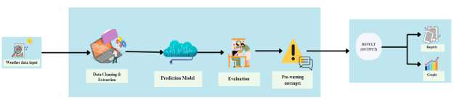**4.1. Block Diagram**

Fig. 1

1. **Data Sources:** The diagram would show various data sources feeding into the system. These likely include:
   * Weather Stations: Providing real-time data on temperature, pressure, humidity, wind speed, and rainfall.
   * Historical Weather Data: Databases or archives storing past weather patterns and cloudburst events.
2. **Data Preprocessing:** This block represents the initial processing of raw data from various sources. It likely includes steps such as:
   * Data Cleaning: Removing noise, outliers, and inconsistencies.
   * Data Integration: Combining data from different sources into a unified format.
   * Feature Extraction: Identifying relevant meteorological features for prediction.
3. **CatBoost Prediction Model:** This is the core component of the system. It represents the CatBoost machine-learning model, which:
   * Analyzes preprocessed data.
   * Predicts the likelihood of cloudburst events based on learned patterns.
4. **Alert Generation:** Based on the predictions from the CatBoost model, this module generates alerts.
   * Thresholds and Rules: Determines when a prediction meets the criteria for issuing a warning.
   * Alert Message Creation: Formats alert messages with relevant information, such as location, severity, and potential impact.
5. **Alert Dissemination:** This component distributes alerts through various channels:
   * Email/SMS: Sends alerts via email and SMS to registered users.
6. **Central Monitoring Center:** This block represents the overall management and control of the system. It likely includes:
   * Data Ingestion and Processing: Manages the flow of data from various sources.
   * Model Training and Evaluation: Retrains and evaluates the CatBoost model to ensure accuracy.
   * System Monitoring: Monitors the health and performance of the system.
   * User Interface: Provides an interface for administrators and users to interact with the system.

**4.2. Modular Diagram**

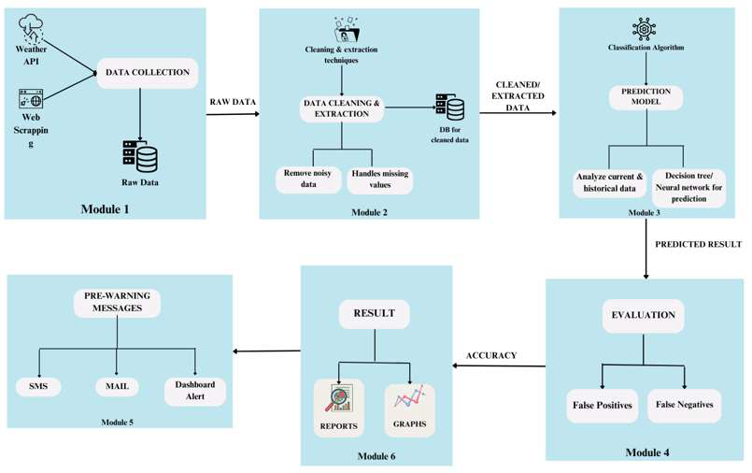

Fig. 2

**Weather Data Input**

The process starts with collecting raw weather data. This data could come from various sources, such as weather stations, sensors, satellites, or meteorological APIs. The data includes information about temperature, humidity, air pressure, precipitation, and other weather-related factors that are necessary to predict cloud bursts.

**Data Cleaning & Extraction**

Once the raw data is collected, it undergoes a cleaning and extraction process:

* Data Cleaning: This step involves filtering out any anomalies or inaccuracies in the data. For example, if a sensor malfunctioned and recorded an unrealistic temperature, that data point would be corrected or removed.
* Data Transformation: The data is often transformed into a suitable format for analysis. This can include converting units (e.g., inches of rainfall to millimeters) or normalizing data to ensure consistency.
* Feature Extraction: Key features relevant to predicting cloud bursts are identified and selected. This could include previous rainfall amounts, atmospheric pressure changes, and temperature fluctuations, which are critical for understanding the conditions leading to a cloud burst.

**Prediction Model**

After preparing the data, it is fed into the prediction model. For this system, we utilize CatBoost, a powerful gradient boosting algorithm that excels in handling categorical features and offers high performance with minimal data preprocessing. CatBoost analyzes historical data patterns and correlates them with current weather conditions to predict the likelihood of a cloud burst. The model is trained on historical weather data, learning to recognize the specific patterns that typically precede a cloud burst. Once trained, CatBoost can process incoming data in real-time, enabling it to generate accurate predictions quickly and effectively.

**Evaluation**

After the prediction is made, it is evaluated for accuracy. The evaluation step involves checking how reliable the prediction is and whether it meets certain performance metrics, such as accuracy or precision. This ensures that the system isn’t sending out false alarms or missing real threats.

**Pre-warning Messages**

If the system detects the possibility of a cloud burst, it generates a pre-warning message. This message is designed to alert relevant authorities or the public about the potential danger, giving them time to take precautionary measures (like evacuation or flood preparation).

**Result (Output)**

Finally, the system produces the results, which are made available in various formats:

- Graphical Representation: Visual outputs such as graphs and charts can illustrate trends

in the weather data, making it easier to understand the dynamics leading to cloudburst

predictions.

**4.3. Project Scheduling & Tracking**

|  |  |  |
| --- | --- | --- |
| TASK | START WEEK | DURATION |
| Problem Identification | 1 | 1 |
| Literature Survey | 2 | 2 |
| Requirement Gathering | 4 | 2 |
| System Design | 6 | 1 |
| Dataset Preprocessing | 7 | 2 |
| Model Training (CatBoost) | 9 | 1.5 |
| API Integration | 10 | 1.5 |
| UI/Dashboard Development | 11 | 1 |
| Email Alert System | 12 | 2 |
| Testing & Debugging | 14 | 1 |
| Performance Evaluation | 15 | 1 |
| Report Finalization | 16 | 1 |

Table 02

Fig.03

**5. Implementation of the Proposed System**

**5.1. Methodology Employed**

**Overview**

The CloudEye project is designed to predict the likelihood of cloudburst events in various cities, providing users with an automated and real-time cloudburst prediction system. Users can register and monitor weather conditions through a RESTful API. This system integrates machine learning models, specifically CatBoost for prediction, and leverages weather data retrieved from the OpenWeather API to enhance the accuracy of cloudburst predictions. Notifications are sent to users via email alerts in case of potential cloudburst warnings.

**Data Collection**

The CloudEye system relies on two types of data

* **Historical Weather Data:** Data from past cloudburst events, including attributes such as rainfall, humidity, wind speed, and temperature, are fed into the CatBoost model for training. This data helps the model learn patterns associated with cloudbursts.
* **Real-time Weather Data:** The OpenWeather API is used to fetch real-time weather data for each city, including rainfall, humidity, and temperature. This data is used for prediction and monitoring.

**Cloudburst Prediction Using CatBoost**

The core of the CloudEye system is the CatBoost machine learning model, which predicts the likelihood of a cloudburst event based on real-time and historical weather data.

**Model Architecture**

CatBoost is a gradient boosting algorithm optimized for categorical data. For this project, it was chosen due to its ability to handle complex interactions between weather attributes and provide accurate predictions.

**1. Training:** The CatBoost model was trained on a dataset containing historical weather patterns, which includes various attributes such as rainfall, humidity, wind speed, and temperature. The dataset also contains labels indicating whether a cloudburst occurred.

The training process involved using data pre-processing techniques like handling missing values, normalizing features, and encoding categorical variables.

**2. Inference:** During prediction, the OpenWeather API provides real-time data, which is fed into the trained CatBoost model. The model outputs a probability score indicating the likelihood of a cloudburst event in the specified city. Based on the prediction threshold, the system determines if an alert should be sent to the user.

**Flask Application:** RESTful API

The CloudEye system is deployed as a Flask web application, which serves as the interface for user interaction. It provides two key routes

● /signup Route: This route handles user registration, where users can provide their email

addresses and select the cities they wish to monitor for potential cloudbursts. The user data is stored in the system’s database for future notifications.

● /predict Route: This route allows users to submit a request to predict the likelihood of a

cloudburst in a specific city. The request triggers the CatBoost model to query the

OpenWeather API for current weather data, and the model's output is returned to the user.

Weather API Integration

The system integrates with the OpenWeather API to retrieve the necessary weather parameters such as:

* Rainfall
* Humidity
* Wind speed
* Temperature
* Precipitation
* Precipitation_hours
* Apparent_temperature

These attributes are used as inputs to the prediction model. Each API call corresponds to the city the user has selected for monitoring.

**Email Notification System**

To keep users informed of potential cloudburst events, the system uses Python’s smtplib to send personalized email notifications.

If the model predicts a high likelihood of a cloudburst, an alert email is generated and sent to the user’s registered email address. The email includes details of the predicted event and suggests safety precautions.

**Evaluation Metrics**

For the CatBoost prediction model, the following evaluation metrics are used:

**1. Accuracy:** Measures the proportion of correct predictions out of all predictions made.

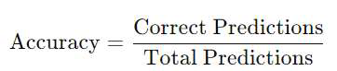

**2. Precision and Recall:** These metrics are crucial for evaluating the model's performance in detecting cloudburst events.

- Precision measures how many of the predicted cloudbursts are actual events:

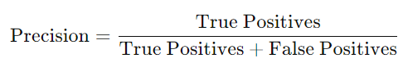

- Recall measures how many of the actual cloudbursts were correctly predicted:

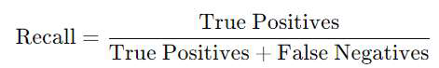

**3. F1 Score:** A metric that balances precision and recall.

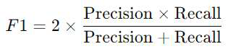

**5.2. Algorithms and flowcharts**

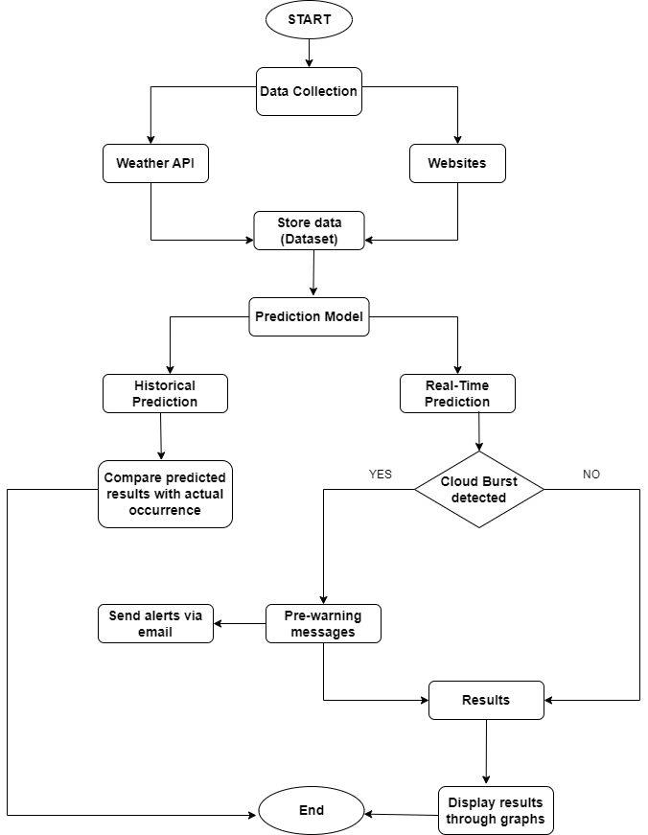**Flowchart:**

Fig.04

**Alogrithm**

**Step 1: Start**

Begin the process.

**Step 2:** **Data Collection**

Collect data from two main sources:

1. Weather API: Fetch real-time weather data.
2. Websites: Gather historical data from various weather websites or other sources.

**Step 3:** **Store Data**

Save the collected data into a dataset for further processing.

**Step 4: Prediction Model**

Use the dataset to feed into a machine learning model for prediction.

The model performs two types of predictions:

1. Historical Prediction: Uses past data to compare the predicted cloud bursts with actual historical occurrences.
2. Real-Time Prediction: Uses live data to predict the likelihood of a cloud burst in real-time.

**Step 5:** **Historical Prediction:**

Compare Predicted Results with Actual Occurrence:

* Validate the model’s predictions by comparing predicted results against actual occurrences.
* If a cloud burst is detected, proceed to alerting.

**Step 6: Real-Time Prediction:**

Cloud Burst Detected?: Check if the real-time prediction identifies a cloud burst.

- Yes: If a cloud burst is detected, send pre-warning messages.

- No: If no cloud burst is detected, proceed to display the results.

**Step 7:** **Pre-Warning Messages**

In case a cloud burst is detected, send pre-warning messages to relevant authorities or users

via email to alert them of the potential hazard.

**5.3. Dataset Description**

The CloudEye project leverages a carefully curated dataset, integrating both historical and real-time weather observations to train and operate its cloudburst prediction system. This comprehensive collection includes a range of meteorological factors known to be critical for accurately predicting cloudburst events, particularly given the localized nature of these phenomena.

1. **Historical Weather Data:**

* This dataset component encompasses past weather patterns and recorded cloudburst events. These records, potentially spanning several years, help the system recognize recurring atmospheric conditions that lead to cloudbursts.
* It's a fundamental resource for training the CatBoost machine learning model, allowing it to learn the complex non-linear relationships between various weather parameters and cloudburst occurrences.
* The time series of historical data allows for identifying trends and seasonal variations that may influence cloudburst events.

1. **Real-Time Data:**

* This provides up-to-the-minute information on current atmospheric conditions using OpenWeatherMap API.
* Data feeds from weather stations, strategically deployed environmental sensors (likely forming a sensor network), and remote sensing data sources like satellites are used.
* The frequency of data updates from these sources is maximized to capture rapidly changing conditions.

## Key Meteorological Factors

The dataset includes the following key meteorological factors:

* **Temperature:** Real-time air temperature measurements at various altitudes, as well as historical temperature records.
* **Wind Gusts:** Maximum instantaneous wind speeds, which can indicate atmospheric instability.
* **Humidity:** Relative humidity levels, a key factor influencing cloud formation and precipitation.
* **Cloud Density:** Cloud cover and thickness, derived from satellite imagery and ground-based observations.
* **Rainfall:** Precipitation measurements from rain gauges and other sources.

**Dataset Curation**

|  |  |  |  |
| --- | --- | --- | --- |
| **Parameter** | **Correlation** | **P-Value** | **Interpretation** |
| **Rain** | 0.772122 | 6.69 × 10⁻⁷¹ | Strong Positive (Significant) |
| **Precipitation** | 0.768599 | 6.95 × 10⁻⁷⁰ | Strong Positive (Significant) |
| **Precipitation Hours (h)** | 0.461585 | 5.63 × 10⁻²⁰ | Moderate Positive (Significant) |
| **Wind Gusts (10m)** | 0.439552 | 4.62 × 10⁻¹⁸ | Moderate Positive (Significant) |
| **Wind Speed (10m)** | 0.232855 | 1.01 × 10⁻⁵ | Weak Positive (Significant) |
| **Pressure (MSL Mean, hPa)** | -0.222249 | 2.58 × 10⁻⁵ | Weak Negative (Significant) |
| **Cloud Cover Mean (%)** | 0.166446 | 1.73 × 10⁻³ | Weak Positive (Significant) |
| **Elevation** | -0.130774 | 1.41 × 10⁻² | Weak Negative (Significant) |
| **Evapotranspiration (ET0, mm)** | -0.122281 | 2.18 × 10⁻² | Weak Negative (Significant) |
| **Temperature (2m)** | 0.096822 | 6.96 × 10⁻² | Weak Positive (Significant) |
| Apparent Temperature | 0.077670 | 1.46 × 10⁻¹ | Weak Positive (Not Significant) |
| Wind Direction (10m) | -0.050502 | 3.45 × 10⁻¹ | Weak Negative (Not Significant) |
| Relative Humidity (2m Mean, %) | 0.001562 | 9.77 × 10⁻¹ | Weak Positive (Not Significant) |

Table 3

**6. Testing of the Proposed System**

**6.1. Introduction to testing**

Testing is a crucial step in the development lifecycle of the CloudEye system to ensure its functionality, reliability, and robustness under various scenarios. Given the life-critical nature of the application—predicting cloudbursts and sending alerts—comprehensive testing was performed at multiple levels. This involved validating both the machine learning model's accuracy and the functionality of the system’s components, including data input, processing, predictions, email alerts, and user interface responsiveness.

**6.2. Types of tests Considered**

To ensure end-to-end functionality, the following types of testing were conducted:

* **Unit Testing**: Individual module such as cloudburst_checker.py was tested to validate their independent correctness.
* **Integration Testing:** This tested the interaction between modules, such as real-time weather fetching, ML-based prediction, and triggering email alerts based on prediction results.
* **System Testing:** The complete CloudEye application, including the database, web interface, and alert system, was tested to ensure it met the functional requirements.
* **Performance Testing:** The system’s prediction latency and email dispatch speed were measured under load to ensure it remains responsive in real-time scenarios.
* **GUI Testing:** Front-end components were tested manually and semi-automatically for responsiveness, data binding, and error-handling.

**6.3 Various test case scenarios considered**

The following test cases were defined and evaluated:

|  |  |  |  |
| --- | --- | --- | --- |
| Test Case ID | Scenario | Expected Output | Status |
| TC_01 | User inputs valid historical weather data | Cloudburst probability is correctly computed and displayed | Passed |
| TC_02 | Real-time weather data triggers alert | Email is sent to user with correct location and safety tips | Passed |
| TC_03 | User signs up with geolocation access enabled | Latitude and longitude auto-filled and saved in database | Passed |
| TC_04 | Database failure during prediction | Error is caught, user notified via GUI, system logs the failure | Passed |
| TC_05 | High concurrent users querying dashboard | Dashboard loads within 2 seconds, no crash observed | Passed |
| TC_06 | Email dispatch with invalid SMTP credentials | Alert fails gracefully with detailed logs for debugging | Passed |
| TC_07 | Safe zone calculation | User receives nearby hospitals/schools as part of alert | Passed |
| TC_08 | Inputting blank or zero weather values | System prompts user to fill mandatory fields | Passed |

Table 04

**6.4. Inference drawn from the test cases**

The results of testing revealed that the CloudEye system is highly stable and meets all specified functional requirements. All major modules, including the prediction engine, email notification system, and database interactions, performed as expected under both normal and stressed conditions.

**Key inferences:**

* The model consistently returned predictions within milliseconds, suitable for real-time use.
* Email alerts were reliably dispatched within seconds of detection.
* The user interface was intuitive and resilient to incorrect inputs.
* Failures in external components (e.g., SMTP or weather API) were handled gracefully, ensuring the system does not crash.

The test cases validate that CloudEye can serve as a dependable early warning system during high-risk weather conditions.

**Chapter 7: Results and Discussion**

**7.1. Screenshots of User Interface (GUI)**



Fig.05. Signup Page



Fig.06. Login Page

The Signup Form is designed to be intuitive and secure, integrating seamlessly with a PostgreSQL database to capture essential user information including name, email, city, and geolocation (latitude and longitude). On signup, the application leverages geolocation services to fetch real-time user coordinates, ensuring personalized alerts. This geospatial data is crucial for targeted notifications in case of cloudburst warnings, directing users to nearby safe zones.

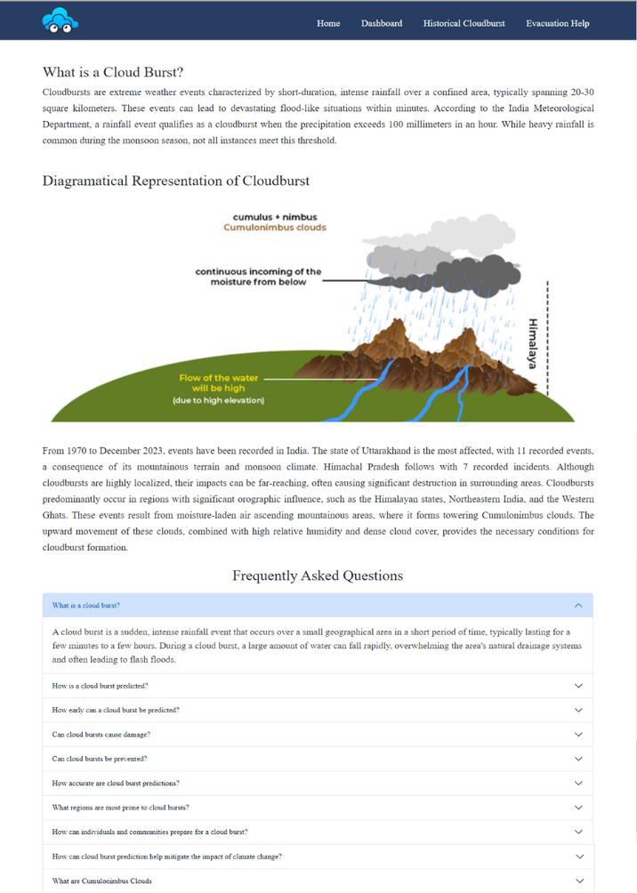

Fig.07.Home Page

The Home page provides a detailed overview of cloudbursts, including a clear explanation of what they are and their potential impacts. It features a visual diagram that illustrates the formation of cloudbursts, helping users understand the process. The page also offers historical context, highlighting regions in India most affected by cloudbursts, such as Uttarakhand and Himachal Pradesh. Additionally, there is an accordion-style FAQ section that answers common questions about cloudbursts, their prediction, impacts, and prevention.

This layout allows users to gain a comprehensive understanding of cloudbursts through informative text, visual aids, and interactive elements.

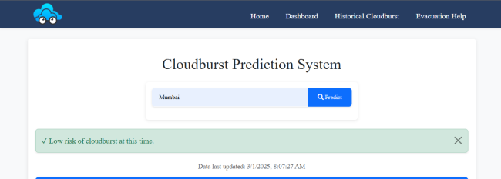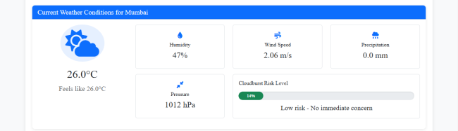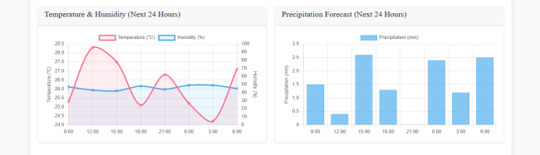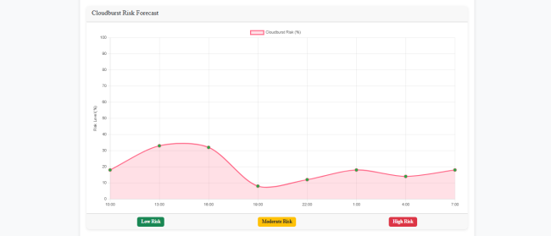

Figure 08. Dashboard

The Dashboard offers users a quick snapshot of real-time weather predictions. Parameters like apparent temperature, precipitation, humidity, and wind speed are visualized through clean, minimalist bar charts and color-coded indicators. The design promotes accessibility, ensuring even non-technical users can interpret forecast data and cloudburst probability at a glance.

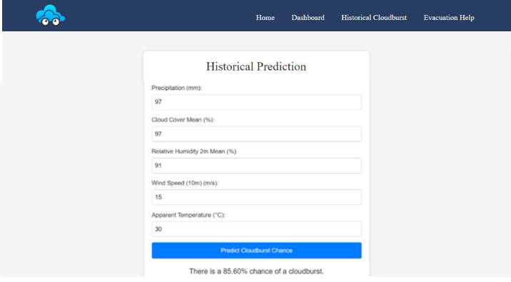

Figure 09. Historical Cloudburst Page

This section empowers users to explore potential cloudburst risks by manually inputting historical meteorological data. Upon submission, the system evaluates parameters such as precipitation, humidity, and wind speed to compute cloudburst likelihood—displayed as a percentage. A prediction of 85.60%, for instance, visually highlights potential threats, supporting proactive disaster planning.

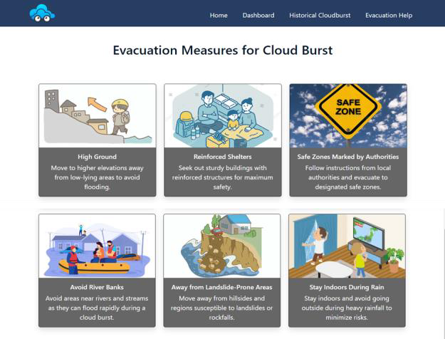

Figure 10. Evacuation Help Page

To enhance community resilience, the Evacuation Help page outlines critical safety protocols. Using iconography and concise text, the interface presents easy-to-follow instructions for safe behavior before, during, and after a cloudburst. This feature helps users prepare for emergencies even without external aid.

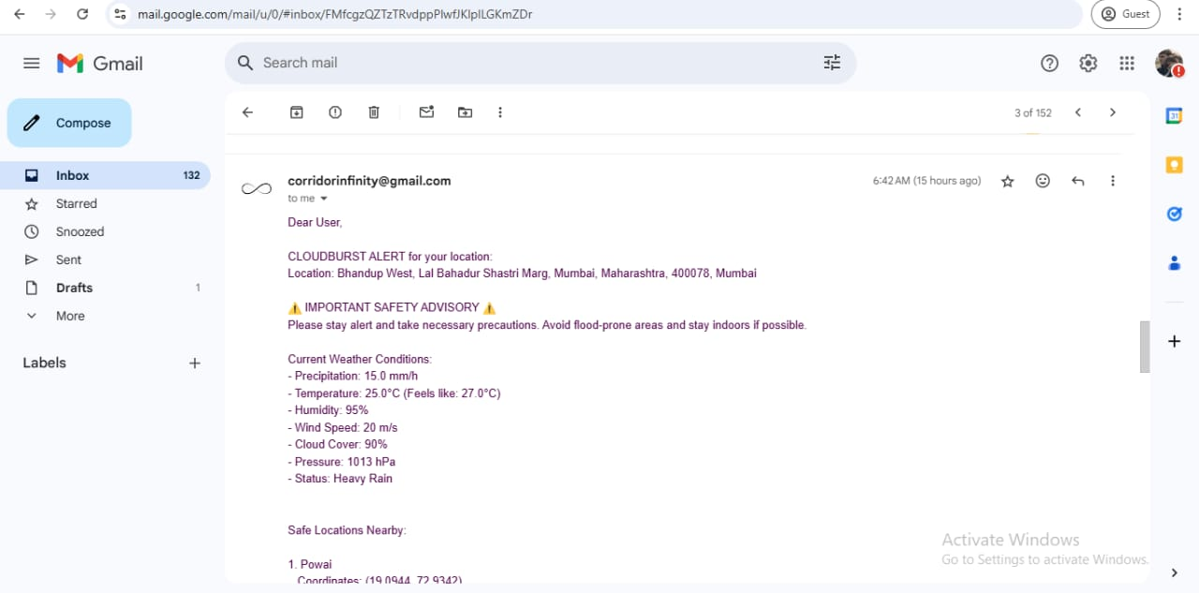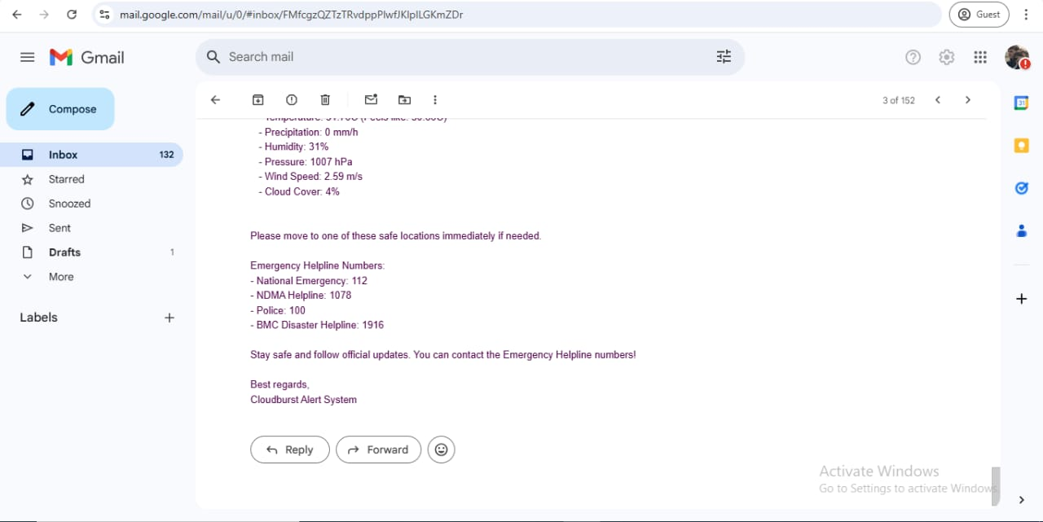

Fig.11.Email Integration

An integral part of CloudEye is its automated email alert system. Based on real-time predictions, users receive customized warnings two hours prior to a detected cloudburst. The system uses the fetch_users() function to pull user data and send_email() to dispatch alerts via Gmail SMTP.

Each email includes:

* Current weather conditions
* Predicted risk percentage
* Nearby safe zones (schools, hospitals, government buildings)
* Emergency contacts  
   This geospatially driven alert mechanism ensures timely evacuation support, potentially saving lives.

**7.2. Performance Evaluation measures**

The CatBoost model was chosen after comparative evaluation due to its superior performance:

* Accuracy: 93.22%
* F1-Score (Class 1): 0.8983  
   It outperforms other models like Random Forest (85.88%) and XGBoost (92.66%) in precision, recall, and F1-score across both classes. CatBoost’s efficiency in handling categorical data, combined with its robustness to overfitting, makes it highly suitable for cloudburst prediction

**7.3. Input Parameters / Features considered**

From the dataset curation process:

* Strong positive correlations: Rain (0.77), Precipitation (0.76)
* Moderate correlations: Precipitation Hours, Wind Gusts
* Weak but significant factors: Wind Speed, Pressure, Cloud Cover, Elevation

Less significant or insignificant features such as Relative Humidity, Apparent Temperature, and Wind Direction were either excluded or assigned lower weights.

The key features used:

* Rain
* Precipitation
* Precipitation Hours
* Wind Gusts
* Cloud Cover
* Pressure (MSL)
* Evapotranspiration
* Elevation

These parameters were selected based on correlation strength and statistical significance (p-value threshold < 0.05).

**7.4. Graphical and statistical output**

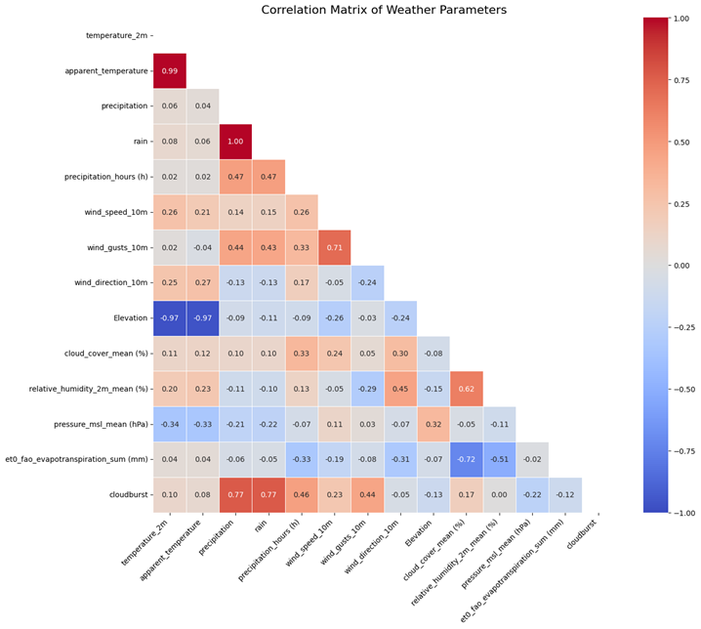

Fig.12

Visualizes Pearson correlations between parameters. Highlights include:

* High positive correlation between Rain and Precipitation (1.00)
* Negative correlations with Pressure and Elevation

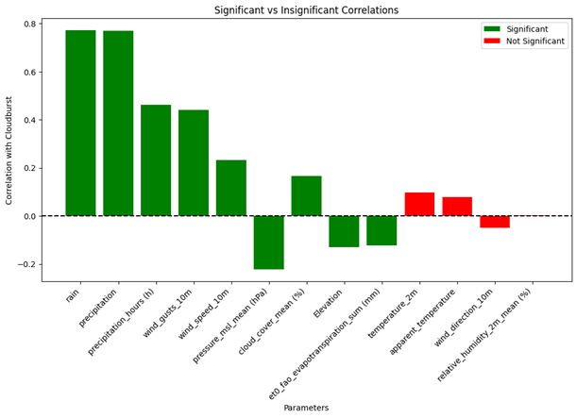

Fig.13.Bar Chart  
 Illustrates which parameters have statistically significant vs. insignificant correlation with cloudburst likelihood.

* Green bars: Statistically significant (Rain, Precipitation, Wind Gusts)
* Red bars: Insignificant (e.g., Apparent Temperature, Relative Humidity)

These visual insights guided feature selection for the ML model.

**7.5. Comparison of results with existing systems**

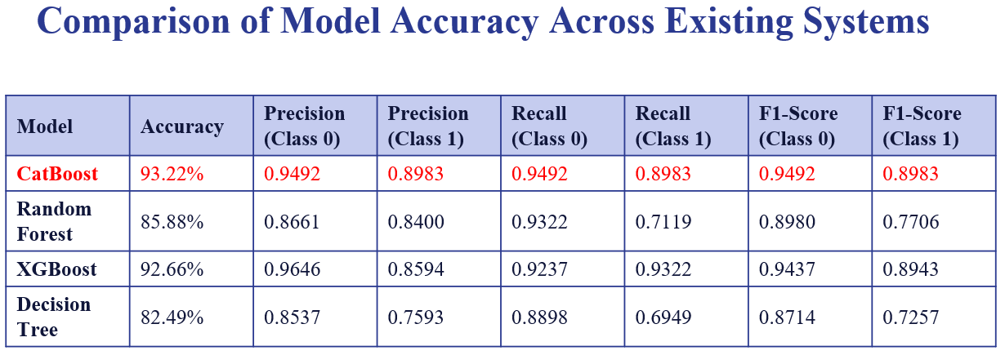As shown in the model comparison table:

Table 05

* CatBoost stands out with the highest accuracy (93.22%) and balanced precision/recall across both classes.
* XGBoost, though close in accuracy (92.66%), underperforms in F1-Score for Class 1.
* Random Forest and Decision Tree models exhibit lower recall and F1-Scores, especially for Class 1, indicating less reliability in predicting cloudburst events.

Thus, CatBoost was finalized as the most reliable and consistent model.

**7.6. Inference drawn**

The results demonstrate the effectiveness of combining geospatial data, meteorological variables, and machine learning to predict cloudbursts. The CatBoost algorithm, supported by a well-curated dataset, achieves high performance and allows timely alerts.

The system’s intuitive GUI, email-based alert mechanism, and integration with real-time and historical data make CloudEye a practical and life-saving solution. It not only contributes to scientific advancements in weather prediction but also empowers communities and authorities with actionable insights and preparedness tools.

**8. Conclusion**

**8.1 Limitations**

The CloudEye system, while offering significant advancements in cloudburst prediction, is subject to certain limitations that should be considered for future development and deployment:

1. **Data Dependency:**
   * The accuracy of the CatBoost model is highly dependent on the quality and quantity of available data. In regions with sparse historical weather data, prediction accuracy may be lower.
   * Real-time data streams from weather stations, sensors, and satellites are essential for the system's operation. Any disruption in these data feeds can affect the reliability of predictions.
2. **Spatial Resolution:**
   * While the system aims to provide localized forecasts, the spatial resolution of available weather data may limit its ability to accurately predict cloudbursts in very small or topographically complex areas.
   * The system relies on data interpolation techniques to estimate weather conditions between data points, which can introduce inaccuracies, especially in areas with limited data coverage.
3. **Computational Resources:**
   * While the CatBoost algorithm is efficient, processing large volumes of real-time data requires significant computational resources.
   * The central monitoring center needs sufficient processing power and storage capacity to handle data ingestion, model execution, and alert generation.
4. **Generalizability:**
   * The CatBoost model is trained on specific datasets from the Himalayan region. Its performance in other geographical areas with different weather patterns may vary.
   * Further research is needed to evaluate the model's transferability and adapt it to other cloudburst-prone regions.

**8.2 Conclusion**

The CloudEye project has successfully developed a cloudburst prediction system designed to provide accurate and timely alerts for vulnerable communities, particularly in the Himalayan region. By integrating advanced weather modeling techniques with the CatBoost machine learning algorithm and real-time data analysis, this system addresses critical limitations in existing prediction methods.

The system's core functionality relies on the CatBoost algorithm, which analyzes historical weather patterns and current atmospheric conditions to predict the likelihood of cloudburst events. This approach enables the CloudEye system to offer improved prediction accuracy and faster response times.

The potential impact of the CloudEye project is significant, offering the possibility of saving lives and minimizing property damage through enhanced prediction accuracy and rapid warning dissemination. This represents a crucial step towards improving disaster preparedness and resilience in regions increasingly threatened by extreme weather events.

**8.3 Future Scope**

The CloudEye system currently provides valuable cloudburst predictions and sends email alerts two hours in advance to registered users in specific locations. To further enhance the system's utility and user experience, the following enhancements are proposed for future development:

1. **Automatic Location Detection and Monitoring:**
   * **Continuous Monitoring:** Enable continuous tracking of the user's location, providing updated cloudburst predictions based on their movement without requiring re-registration or manual updates.
   * **Real-Time Updates:** The system will dynamically fetch weather data based on the user's detected location and provide immediate cloudburst risk assessments, updating predictions in real-time.
2. **Enhanced Alert Delivery:**
   * Proactive Push Notifications: Transition from email alerts to proactive push notifications via a dedicated mobile application. This would provide more immediate and reliable warnings directly to users' devices.
   * Location-Based Alerts: Refine alert delivery to target users in immediate danger zones, providing geographically precise warnings.
3. **Advanced Modeling Techniques:**
   * Integration of Nowcasting Models: Incorporate short-term, high-resolution weather models (nowcasting) to refine the accuracy of immediate cloudburst predictions.
4. **Offline Functionality:**
   * Limited Offline Access: Allow users to access previously downloaded maps and safety information even without an active internet connection. This would be particularly useful in remote areas with unreliable connectivity.

These enhancements would transform CloudEye from a system providing scheduled email alerts to a dynamic, proactive, and personalized cloudburst warning system. By leveraging advances in geolocation, mobile technology, and data integration, CloudEye can significantly improve its effectiveness in protecting vulnerable communities from the devastating impacts of cloudburst events.

**References**

[1] D. Karunanidy, N. M., P. S. Rakshith, M. N., G. Sireesha, and M. Sreedevi, "Cloudburst Prediction in India Using Machine Learning," in Proc. 2023 IEEE Int. Conf. Big Data, 2023.

[2] A. Mittal and S. K. Khatri, "Environment Monitoring Using Internet of Things – Cloud Burst Prediction," in Proc. 2019 1st Int. Conf. Advances Inf. Technol. (AICAI), 2019, pp. 1-6, doi: 10.1109/AICAI.2019.8701364.

[3] M. Sivagami, "Sequence Model based Cloudburst Prediction for the Indian State of Uttarakhand," Disaster Advances, vol. 14, no. 7, June 2021.

[4] S. Das, R. Ashrit, and M. W. Moncrieff, "Simulation of a Himalayan cloudburst event," *J. Earth Syst. Sci.*, vol. 115, no. 3, pp. 299–313, June 2006.

[5] A. Sebastian, J. B. Thomas, R. Mathew, R. Jose, and A. Manuel, "SkySentinel: Harnessing AI for Cloudburst Forecasting and Warning," 2023 International Conference on Circuit Power and Computing Technologies (ICCPCT), Kollam, India, 2023, pp. 1-10, doi: 10.1109/ICCPCT58313.2023.10246006.

[6] "Cloudburst," *Wikipedia*, [Online]. Available:<https://en.wikipedia.org/wiki/Cloudburst>.

[7] K. S. Thakur, "What are cloudbursts and why are they increasing in India?" *Down to Earth*, 25-Sep-2022. [Online].

[8] S. Singh and M. L. Kansal, "Cloudburst—A Major Disaster in The Indian Himalayan States," in *Disaster Management and Risk Reduction in Climate Change*, 2022, pp. 115-126. doi: 10.1007/978-981-16-5312-4_9.

[9] H. Chikoore, M.-J. Bopape, T. Ndarana, T. P. Muofhe, M. Gijben, R. B. Munyai, T. C. Manyanya, and R. Maisha, "Synoptic structure of a sub-daily extreme precipitation and flood event in Thohoyandou, north-eastern South Africa," *Weather and Climate Extremes*, vol. 33, p. 100327, 2021. doi: 10.1016/J.WACE.2021.100327.

[10] G. V. Kumar, P. Srinivas, K. Jain, A. Gairola, and R. K. Singh, "Hydrodynamic simulation of a cloudburst event in Asi Ganga Valley of Indian Himalayan region using MIKE11 and GIS techniques," *Mausam*, vol. 69, no. 4, pp. 523-534, 2021. doi: 10.54302/MAUSAM.V69I4.351.

**Appendix I**

### a. List of Figures

|  |  |  |
| --- | --- | --- |
| **Fig. No.** | **Title** | **Chapter No** |
| Fig. 01 | Block Diagram of the CloudEye System | Chapter 4 |
| Fig. 02 | Modular Design of the CloudEye System | Chapter 4 |
| Fig. 03 | Gantt Chart – Project Scheduling and Tracking | Chapter 4 |
| Fig. 04 | System Flowchart for CloudBurst Prediction | Chapter 5 |
| Fig. 05 | Signup Page | Chapter 7 |
| Fig. 06 | Login Page | Chapter 7 |
| Fig. 07 | Home Page Layout | Chapter 7 |
| Fig. 08 | Dashboard – Real-time Predictions | Chapter 7 |
| Fig. 09 | Historical Cloudburst Prediction Page | Chapter 7 |
| Fig. 10 | Evacuation Help Page | Chapter 7 |
| Fig. 11 | Email Integration and Sample Alert | Chapter 7 |
| Fig. 12 | Pearson Correlation Heatmap | Chapter 7 |
| Fig. 13 | Bar Chart – Feature Significance Analysis | Chapter 7 |

### b. List of Tables

|  |  |  |
| --- | --- | --- |
| **Table No.** | **Title** | **Chapter No** |
| Table 01 | Comparison with Existing Systems (MM5, CatBoost, SkySentinel) | Chapter 2 |
| Table 02 | Project Activity Table – Start Week and Duration | Chapter 4 |
| Table 03 | Dataset Curation – Parameter Correlation and Significance Values | Chapter 5 |
| Table 04 | Test Case Scenarios and Expected Outputs | Chapter 6 |
| Table 05 | Model Comparison – Accuracy, F1 Score, and Evaluation Metrics | Chapter 7 |